Bài 1
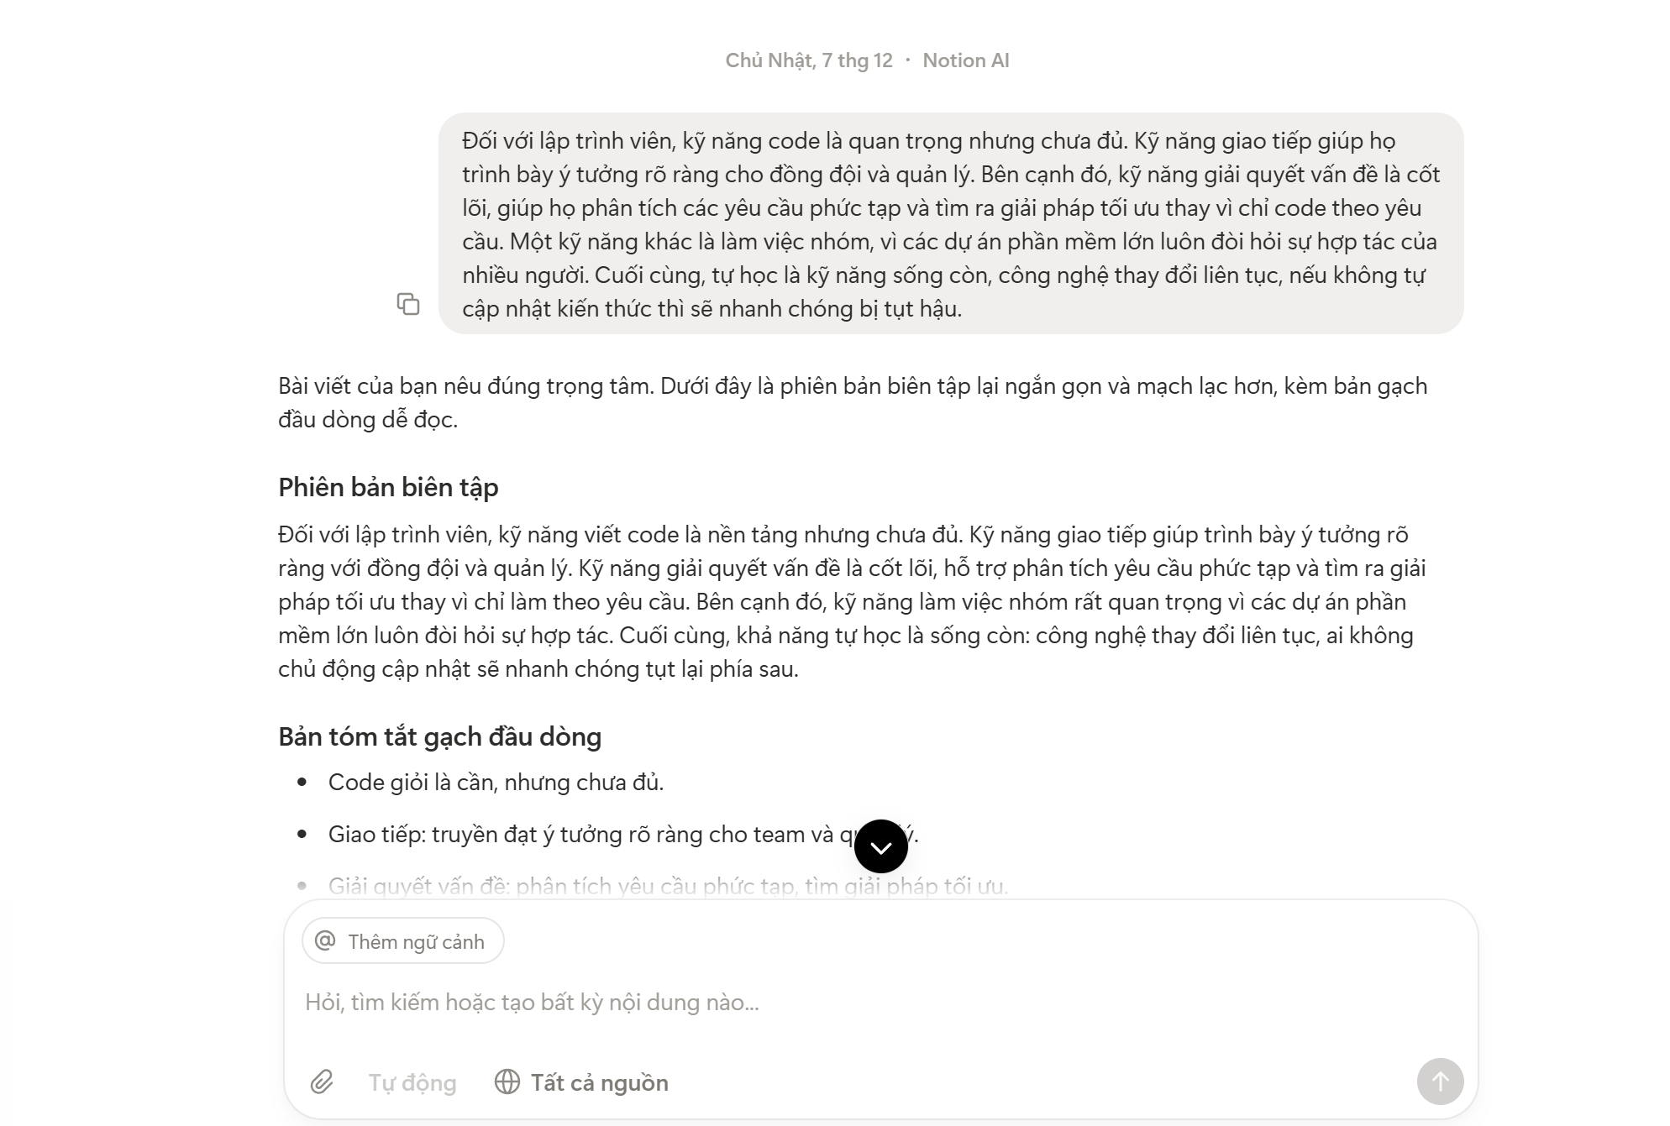
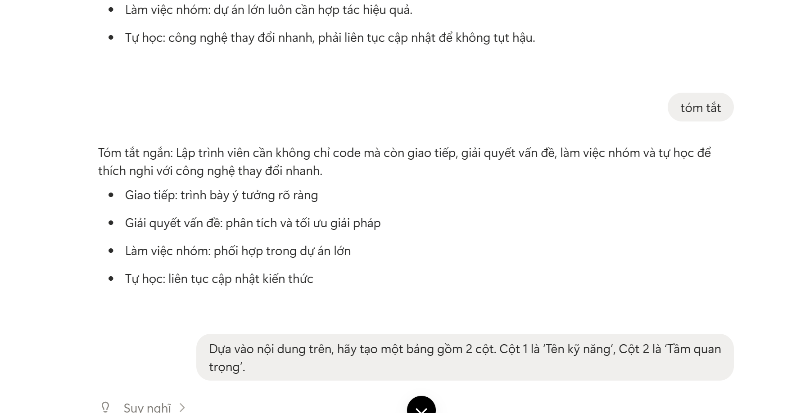
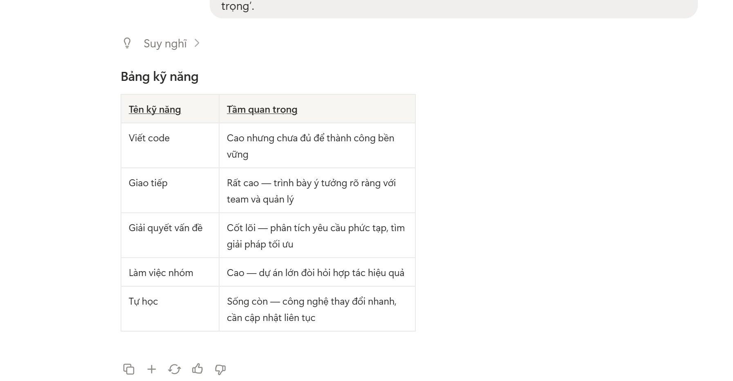

Bài3
https://gamma.app/docs/Deepfake-va-Nhung-Anh-Huong-en-Xa-Hoi-1w7l0p09ipkh0zx

